1) Initialize the Repository

npm init

2)Install express

Using express for the complete routing in node API service/application

npm install –save express

3)Install morgan

Displays the requests from the front end the responses sent for those requests

npm install morgan

app.use(morgan('tiny'));

Use this command in app.js/index.js for displaying the shortnotes of the req and res

4)Install Chalk

For coloring the output/logs

Npm install –save chalk

5)Install body parser

For automatic parsing of req, res body – an abstraction layer

npm install –save body-parser

6)Install debug

Use debug to display the logs only in dev mode

The logs will not be displayed prod mode

npm install –save debug

const debug = require('debug')('app');

Run from npm scripts

"scripts": {

"start": "set DEBUG=app & nodemon app.js",

7)Install Nodemon

Hot reload for node js

Npm install –save nodemon

Add the nodemon configuration in app.js

"nodemonConfig": {

"restartable": "rs",

"ignore": [

"/node_modules/**"

],

"env": {

"PROCESS_ENV": "Developement",

"PORT": 8000

}

}

8)Install eslint

For following a particular lint architecture employing international standard

First of all do,

npm install -g eslint

for a global installation of eslint

Npm install –save-dev eslint

Add lint to scripts

"scripts": {

"start": "set DEBUG=app & nodemon app.js",

"lint": "eslint app.js",

Do eslint –init to initialize the .eslint config file in your application

The configuration file will be added

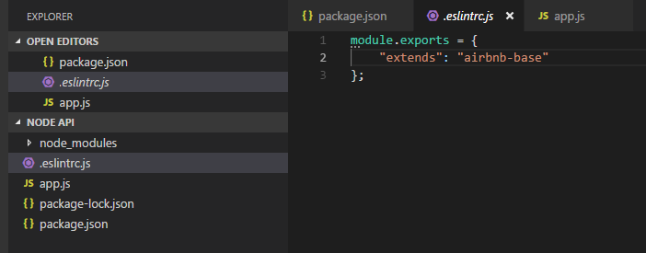

If you want, you can addd rules in the eslint config file

module.exports = {

"extends": "airbnb-base",

"rules":{

"linebreak-style": 0,

"indent": ["error", 4],

"no-console": 0,

"no-unused-vars": 0,

"array-callback-return": 0

}

};

To run the command, use command

npm run lint

If success, nothing will be displayed.

If any linting errors are found, it will display failure message

9)Install path

Npm install –save path

For path related operations

Sample usage,

path.join(__dirname, '/node_modules/bootstrap/dist/css')

10) Use mongodb or mongoose

Mongoose – Schema based – Relational database type

Use mongoose for small and faster application

For bigger and heavyweight applications, use mongodb